Implementing OAuth in Java Web Application

OAuth (open authorisation) is a protocol using which a third party application can access a part of user’s account information like name, age, dob, friend list etc. after authorization by the user.

Players involved in outh

1. Service provider – which provides some kind of service
2. Third party application (Client application) – Which wants to access a part of users account information
3. User which gives permission to access a part of his accounts information

Before a third, party application can access user’s data it must be registered with the service provider.

Lets take an example to see the end-to-end process where a third party application (client application) - “OAuth client” wants to access basic users account information from google.

Step 1 – Register “OAuth client” with google.

Create a project in google developer console

<https://console.developers.google.com/projectselector/apis/dashboard?authuser=1&organizationId=0>

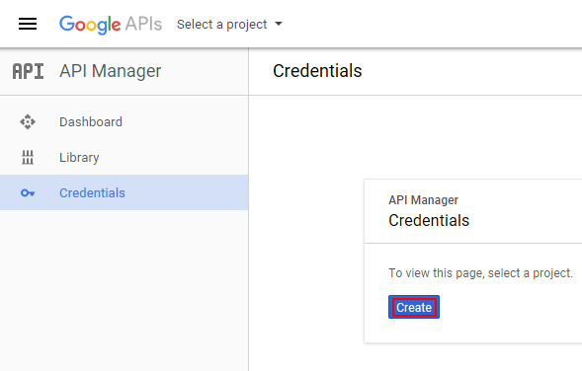

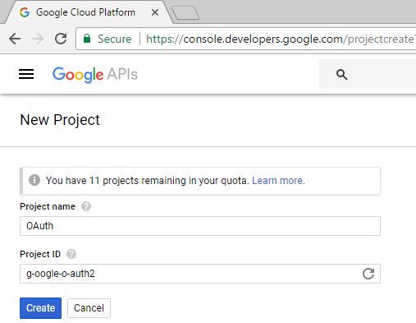

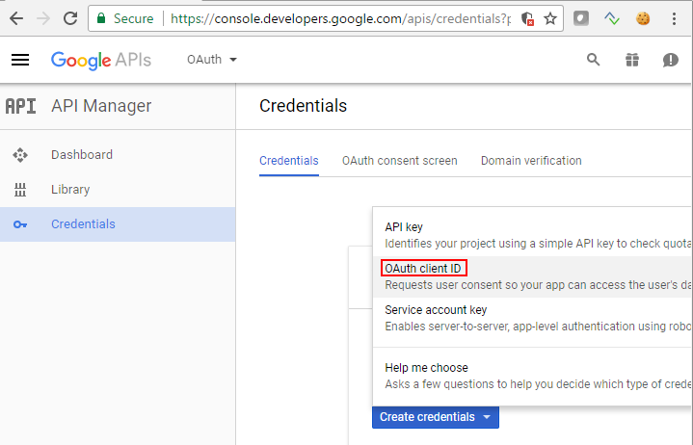

Configure the consent screen

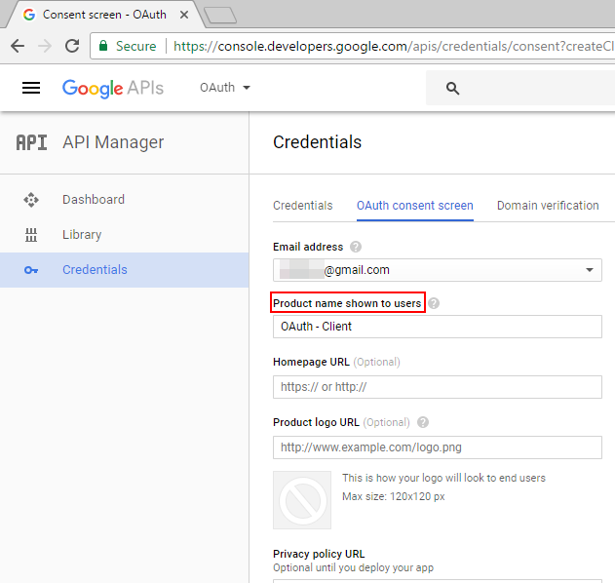

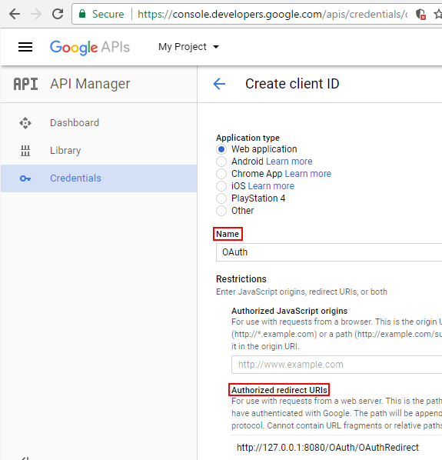

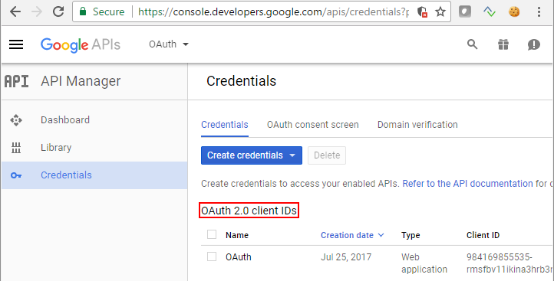

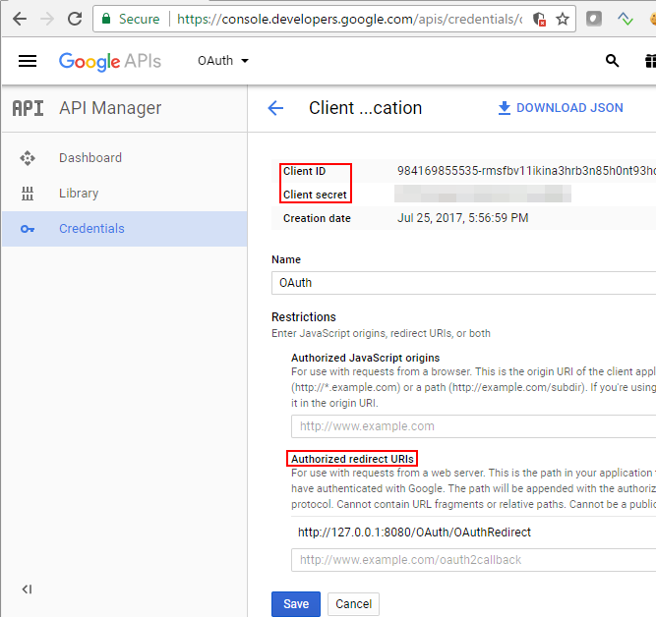

Details everything here

Step 2 – Create a web application to access a users basic info and display it back to the end user. I am using sribe java library to implement oauth.

Project structure

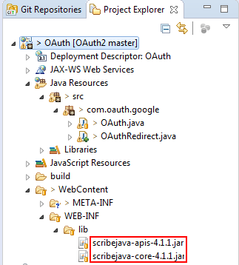

Clientid – id that we got at the time of creting registering our application

Client seret – secret that we got at the time of registering our appl